Three sum problem :
given an array and a value, find there eissx three numbers whose sum is equal to the given value.

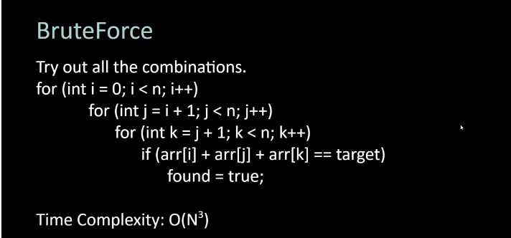
Procedure :
we reduce this problem to two pointer problem by fixing one number.
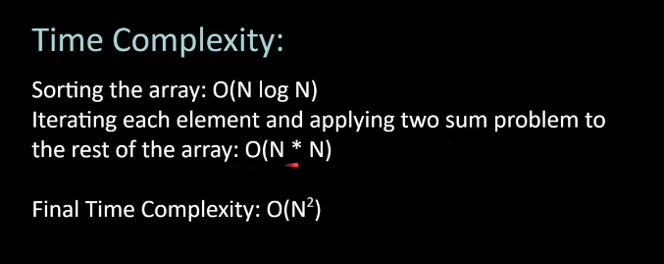
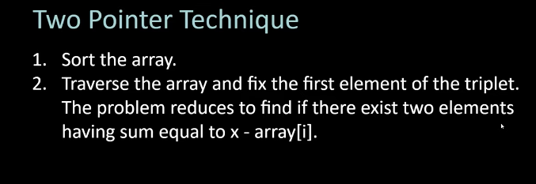

#include<bits/stdc++.h>
using namespace std;

void exists(vector<int>a , int target){
sort(begin(a),end(a));
bool flag=false;
int n= a.size();
for( int i=0 ;i<n; i++){
int lo=i+1 , hi=n-1;
while(lo<hi){
int cur= a[i]+a[lo]+ a[hi];
if(cur==target){
flag=true;
break;
}
else if(cur<target){
lo++;
}
else{
hi--;
}
}
}
cout<<flag;
}
int main(){
int target;
cin>>target;
vector<int>a={1,2,3,7,1,6,9};
exists(a,target); }

